Group 4:
For our team:
3 people working
Velocity = 0.5
3 iterations

1 calendar month 20 working days
Iteration | Included Priorities | Total Days | Purpose
Iteration 1 | 10 and 20 | 21 days | Build core carpark search and display features
Iteration 2 | 30 and 40 | 6 days | Add recommendation and user account functions
Iteration 3 | 50 | 6 days | Add optional mobile, history, and admin features

Item | Details
Team members | 3
Velocity | 0.5
Iteration length | 20 working days
Maximum work per iteration | 10 days
Day count started | Last week

Iteration 1
No. | Title | Priority | Days | Status
1 | Search Nearby Carparks | 10 | 5 | Done
2 | View Available Lots | 10 | 5 | Done
3 | View Carpark Details | 10 | 5 | Done
4 | Search by Area or Address | 20 | 1 | In Progress
5 | Sort Carparks | 20 | 1 | In Progress
Total |  |  | 17 days

Iteration 2
No. | Title | Priority | Days | Status
6 | View Carparks in List | 10 | 3 | Done
7 | View Carparks on Map | 20 | 1 | Done
8 | Recommend Best Carpark | 30 | 3 | Done
9 | Save Favourite Carparks | 40 | 1 | Done
10 | Register Account | 40 | 1 | Done
11 | Login Account | 40 | 1 | Done
12 | Carpark Detail Panel | 40 | 3 | ToDo
13 | Frontend Architecture Refactor | 40 | 3 | ToDo
Total |  |  | 16

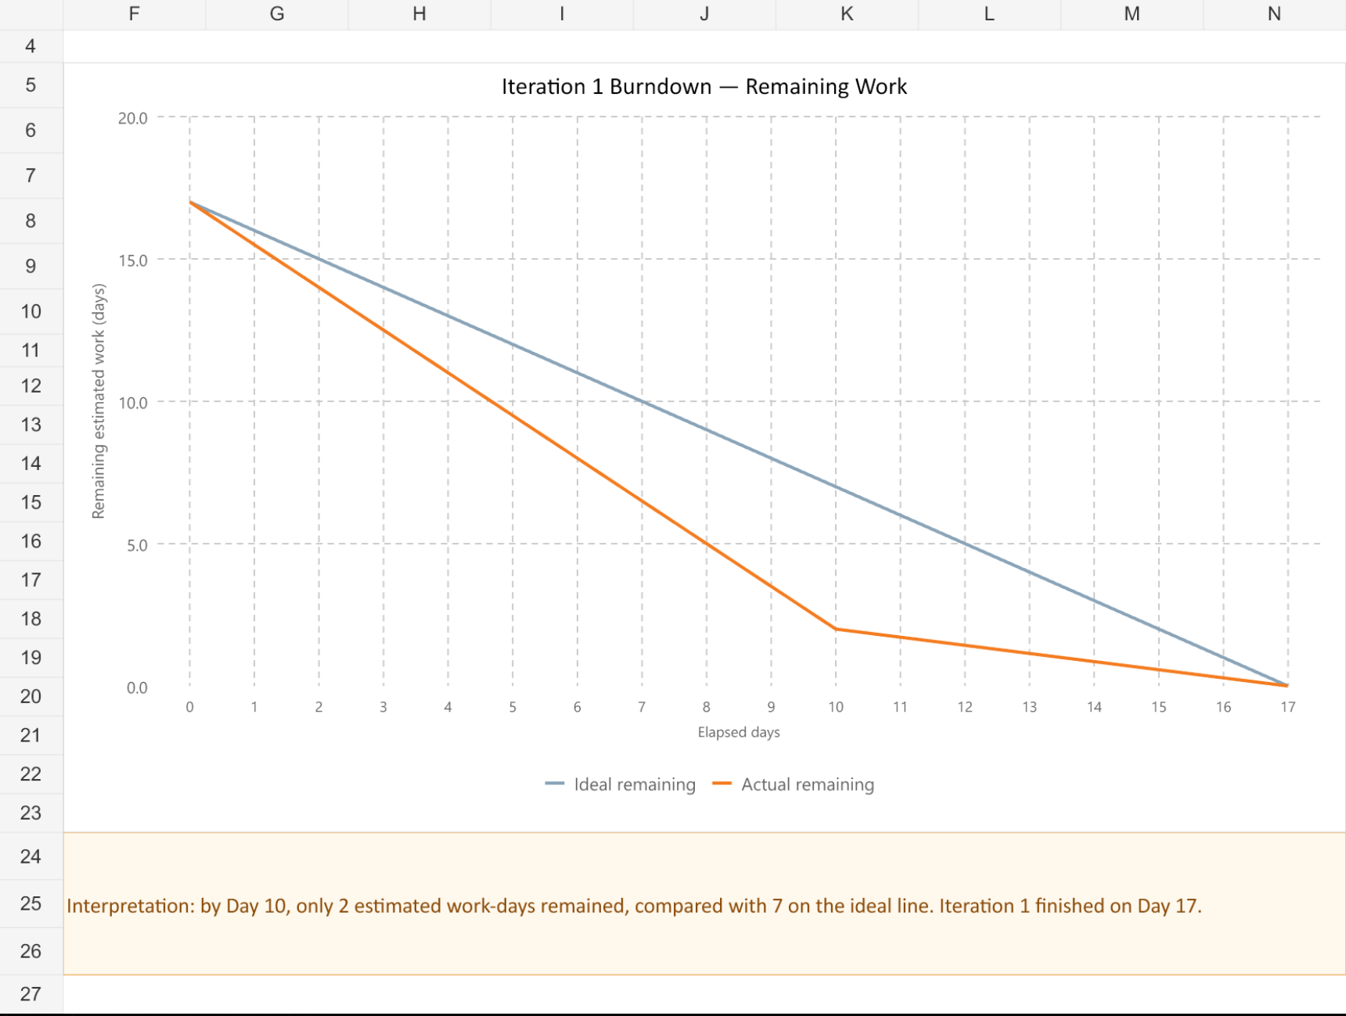33

Iteration 3
No. | Title | Priority | Days | Status
14 | Mobile-Friendly Website | 50 | 3 | Todo
15 | View Search History | 50 | 1 | Todo
16 | Admin View Records | 50 | 2 | Todo
Total |  |  | 6 days

